The University of Strathclyde

Analysis of Applicability of Accelerometer and Gyroscope for Motion Capture and Classification in Cattle

Angelita de Castro Fernández Torres, Victor Hugo da Silva Costa, Dr. Walter Craig Michie, Department of Electronics and Electrical Engineering at the University of Strathclyde, Glasgow, United Kingdom

12th June, 2014

Abstract

The monitoring of a cow behaviour can provide valuable information regarding the moment of calving. Make a comparison between the use of accelerometers and gyroscopes with focus on patterns in cows’ behaviour near the moment of calving is a way to optimize production. Previous researches within this project already stated that the most significant behaviour to be monitored, for this purpose, is the frequency of tail raisings. Our main aim is identify which kind of sensor best fits this kind of system, providing more accurate and significant data. The major advanced proposed by this kind of system is perform an truthful algorithm able to find out when the cow is near the moment of give birth and send an alert to the farm with the location and information about this specific cow, reducing the number of deaths during the calving process.

# Introduction

This document presents the statement of intents for a project based on comparison between accelerometers and gyroscopes with focus on patterns in cows’ behaviour near the moment of calving. Previously, a lot of different indicators regarding cows’ behaviour have been analysed. The most significant among all of them is the frequency of tail raisings. Compared with other monitored parameters, tail raising showed the biggest difference between a standard and a near-birth behaviour. For this project, during two months, we will collect data from accelerometer and gyroscope and compare results, finding which kind of sensor performs better for our objective. Also, we will process this data and check if we are able to get new information whilst using gyroscope. The report is structured as follows:

* Section 2 introduces the reader to the basic concepts regarding the use of accelerometers and gyroscopes, within navigation systems.
* Section 3 states about the pursuit of better results using gyroscopes instead of accelerometers.
* Section 4 introduces our time management for this project.
* Section 5 enunciate the methodology of this research and other relevant aspects concerning the project management.
* Section 6 aver about the current state of this project.

# Background Review

## R Language

R is a free software environment for statistical computing and graphics. It compiles and runs on a wide variety of UNIX platforms, Windows and MacOS

R is an integrated suite of software facilities for data manipulation, calculation and graphical display. It includes data handling and storage facility, a suite of operators for calculations on arrays, in particular matrices, a large integrated collection of intermediate tools for data analysis, graphical facilities for data analysis and display either on-screen or on hardcopy, and a programming language which includes conditionals, loops, user-defined recursive functions and input and output facilities.

R provides a wide variety of statistical (linear and nonlinear modelling, classical statistical tests, time-series analysis, classification, clustering and etc.) and graphical techniques, and is highly extensible. [7]

It was chosen in this study for data processing since it is efficient in data storage and analysis.

We deal with a large amount of data coming from the sensors, but this need to be translated to something more comprehensible. Without the data processing all we have is a series of waves. Using R, it is possible to transform this signal and visualize it in frequency domain instead of time domain and other useful applications during the data processing.

For all of the reasons above, R is the software environment chosen.

## Accelerometer

An accelerometer is a sensor that measures the physical acceleration experienced by an object due to inertial forces or due to mechanical excitation.(Lawrence, as cited by Siva Prasad, M. S. Y., 2011) [5]

There are different types of accelerometer, but one of the most popular and useful is the MEMS Accelerometer, a relatively simple device.  MEMS stands for Micro Electronic Mechanical Systems, which is technology that allows to produce very small devices.

A MEMS Accelerometer provides crucial advantages such as the low cost, low power consumption of these devices.  Also, testing is not restricted to a laboratory environment; accelerometers are small which enables subjects to walk relatively unrestricted. A variety of accelerometer designs offer diversity of dynamic range and sensitivity; and direct measurement of 3D accelerations eliminates errors associated with differentiating displacement and velocity data. [1]

A MEMS accelerometer is not as accurate as accelerometers manufactured using traditional techniques, though the large investment in MEMS is improving it quickly.

Conceptually, an accelerometer behaves as a damped mass on a spring. When the accelerometer experiences acceleration, the mass is displaced and the displacement is then measured to give the acceleration [5]

When a mass–spring system is submitted to a compression or stretching force due to movement, the spring will generate a restoring force proportional to the amount of compression or stretch.

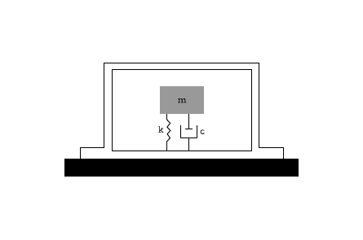

Figure 1: Typical basic accelerometer schematic.

A simple accelerometer consists in a proof mass, also called seismic mass, attached to a spring parallel to a dashpot, evolved by a case.

## Gyroscope

A gyroscope is a sensor able to measure orientation based on principles of angular momentum. This kind of sensor is used in combination with an accelerometer sensor in most of all strapdown inertial navigation systems, as shown in figure 2.

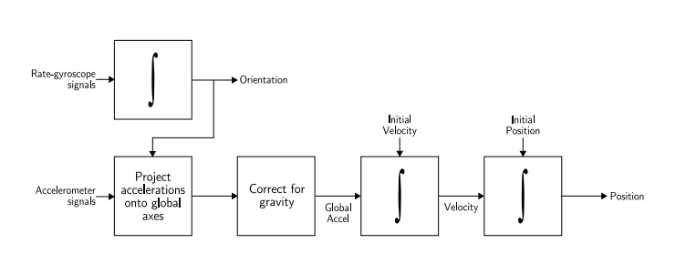

Figure 2: Strapdown inertial navigation algorithm. (source: [6]).

There are several types of gyroscopes, and as stated before on accelerometer section, one of them is the MEMS Gyroscope. MEMS gyroscopes can consist of as few as three parts. [6]

Conceptually, a MEMS gyroscope act as a Foucault pendulum and is characterised as a vibrating structure gyroscope, or according with IEEE, as a Coriolis vibratory gyroscope.

# Motivation

Accelerometers and gyroscopes are key elements to inertial navigation. There are many different uses to movement sensors, such as vehicles acceleration measurement, detecting machinery movement and mobile application. They are widely used in tablets and smartphones for interface control (detecting the position of the screen), which made motion sensors like accelerometers and gyroscopes very popular and consequently cheaper.

The objective of this project is to quantify and analyse the movement of cows in order to map their behaviour and determine which activity they are performing suing movement sensors. There is already a study about monitoring cows’ activities using accelerometers[], but the objective of this study is to determine if a gyroscope can achieve more precise results, which is viable since their price dropped substantially.

A sensor can be attached to a cow’s tail or neck and we want to be able to identify what are they doing based on the data from the sensor (calving, ruminating, sleeping). Based on previous studies, it was possible to identify patterns at the tail’s movement that indicates calving. An interesting comparison would be collect and process data from the tails movement using a gyroscope. This is going to determine which sensor should be used at the hardware design of the device for future studies.

# Time Management

For time management, and overview of the whole project can be found at table 1.

|  |  |  |  |  |  |  |
| --- | --- | --- | --- | --- | --- | --- |
| **#** | **Task Name** | **Start Date** | **End Date** | **Duration (days)** | **Predecessors** | **% Complete** |
| 1 | Background Review | 29/05/2014 | 16/06/2014 | 13 |  |  |
| 2 | Interim Report | 29/05/2014 | 06/12/2014 | 11 |  | 100% |
| 3 | Progress Meetings | 29/05/2014 | 11/08/2014 | 53 |  | 25% |
| 4 | *Accomplished* | 29/05/2014 | 11/08/2014 | 53 |  | 25% |
| 5 | *1st Meeting* | 29/05/2014 | 29/05/2014 | 0 |  | 100% |
| 6 | *2nd Meeting* | 03/06/2014 | 06/03/2014 | 0 |  | 100% |
| 7 | *3rd Meeting* | 10/06/2014 | 06/10/2014 | 0 |  | 100% |
| 8 | *4th Meeting* | 16/06/2014 | 16/06/2014 | 0 |  |  |
| 9 | *5th Meeting* | 23/06/2014 | 06/23/2014 | 0 |  |  |
| 10 | *6th Meeting* | 30/06/2014 | 06/30/2014 | 0 |  |  |
| 11 | *7th Meeting* | 07/07/2014 | 07/07/2014 | 0 |  |  |
| 12 | *8th Meeting* | 14/07/2014 | 14/07/2014 | 0 |  |  |
| 13 | *9th Meeting* | 21/07/2014 | 21/07/2014 | 0 |  |  |
| 14 | *10th Meeting* | 28/07/2014 | 28/07/2014 | 0 |  |  |
| 15 | *11th Meeting* | 04/08/2014 | 04/08/2014 | 0 |  |  |
| 16 | *12th Meeting* | 11/08/2014 | 11/08/2014 | 0 |  |  |
| 17 | Accelerometer Tests | 03/06/2014 | 30/06/2014 | 20 |  | 45% |
| 18 | Gyroscope Tests | 18/06/2014 | 08/07/2014 | 15 |  | 0% |
| 19 | Data Processing | 09/07/2014 | 05/08/2014 | 20 | 18, 17 | 0% |
| 20 | Poster | 06/08/2014 | 19/08/2014 | 10 | 19 | 0% |
| 21 | Poster Submission | 14/08/2014 | 14/08/2014 | 0 |  |  |
| 22 | Poster Presentation | 20/08/2014 | 26/08/2014 | 5 | 20 | 0% |
| 23 | Final Report | 28/08/2014 | 22/08/2014 | 20 |  | 0% |

All tasks assignment to A. C. F. Torres and V. H. S. Costa

*An image with a graphic overview of this Gantt chart can be accessed at* [*http://bit.ly/1pnPKQx*](http://bit.ly/1pnPKQx)

Table 1: Table view of Project Gantt Chart.

# Procedure

The study of movement sensors for motion capture has substantially increased. A background review including relevant articles about the subject is necessary to understand the fundamental principles of the project. The first step is to understand what an accelerometer and a gyroscope are, how they work and how they could be utilized in this study. Since the accelerometers are already available, the first tests were made and compared to the data collected previously in the farms from the cows.

Based on the previous information from the study made with the accelerometer it was noticed that the easier behaviour to identify was calving, through the tail raise.

It is necessary to run the same tests utilizing a gyroscope, collect data from the sensor and store at the database for future comparisons and/or analysis.

To compare the results the data collected needs to be processed using R, plot the waveforms and check which sensor gives the most precise result.

If this part is successful, another behaviours can be analysed and tested using the most appropriated sensor (Accelerometer or Gyroscope).

The results will be described in a detailed report and presented in a poster.

# Progress

At the beginning of the project some reading material [6] was given to the background review and setting with the terminology and basic concepts surrounding this kind of project. This literature given us knowledge about the different types of inertial navigation systems, the variety of sensor available and some basic concepts within strapdown inertial navigation.

More literature was researched with the intent to provide a better understanding of the applications and what is already done in our field of actuation. Most of these resources stated about monitoring systems used in humans. The concept beneath these projects is almost the same as ours, finding patterns in human behaviour using accelerometer/gyroscope-based systems.

Some dummy data was gathered using an accelerometer with the purpose to understand with hands-on how this kind of device works. Relevant data was provided by our advisor and his assistant. This data started to be processed using R language, as a study activity, now we are able to make basic digital signal processing (i.e. find the spectrum of a 1-D signal), as shown in figure 3.

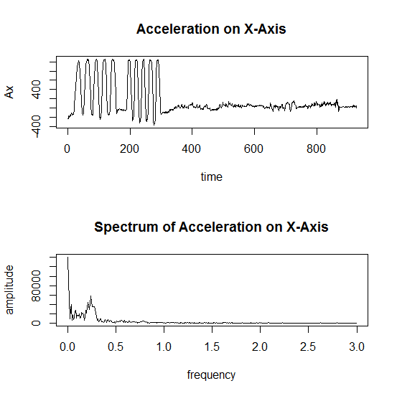

Figure 3: Example of digital signal processing to find spectrum of 1-D signal using R language.

# References

|  |  |
| --- | --- |
| [1] | Kavanagh, J. J., & Menz, H. B. (2008). Accelerometry: A technique for quantifying movement patterns during walking. *Gait & Posture*, *28*(1), 1–15. doi:10.1016/j.gaitpost.2007.10.010 |
| [2] | Mantyjarvi, J., Lindholm, M., Vildjiounaite, E., Makela, S.-M., & Ailisto, H. A. (2005). Identifying users of portable devices from gait pattern with accelerometers. In *IEEE International Conference on Acoustics, Speech, and Signal Processing, 2005. Proceedings. (ICASSP ’05)* (Vol. 2, p. ii/973–ii/976 Vol. 2). doi:10.1109/ICASSP.2005.1415569 |
| [3] | Lee, M.-W., Khan, A. M., Kim, J.-H., Cho, Y.-S., & Kim, T.-S. (2010). A single tri-axial accelerometer-based real-time personal life log system capable of activity classification and exercise information generation. *Conference Proceedings: ... Annual International Conference of the IEEE Engineering in Medicine and Biology Society. IEEE Engineering in Medicine and Biology Society. Conference*, *2010*, 1390–1393. doi:10.1109/IEMBS.2010.5626729 |
| [4] | Karantonis, D. M., Narayanan, M. R., Mathie, M., Lovell, N. H., & Celler, B. G. (2006). Implementation of a real-time human movement classifier using a triaxial accelerometer for ambulatory monitoring. *IEEE Transactions on Information Technology in Biomedicine: A Publication of the IEEE Engineering in Medicine and Biology Society*, *10*(1), 156–167. |
| [5] | Siva Prasad, M. S. Y. (2011). Design simulation and fabrication of micromachined acceleration sensor. *INFLIBNET*. Retrieved from  http://shodhganga.inflibnet.ac.in:8080//handle/10603/2272 |
| [6] | Woodman, O. J. (2007). An introduction to inertial navigation. *Technical Report - Number 696. Computer Laboratory. University of Cambridge. United Kingdom. Technical Report*, *2007*, UCAM-CL-TR-696 / ISSN 1476-2986 |
| [7] | The R Foundation for Statistical Programing (2014). *What is R?* Retrieved from  www.r-project.org/about.html |